ASE LAB 3 ASSIGNMENT

Name : Vishnu Praveen Gude

ID : 16103389

IDEA: Mixing google maps service and openweathermap.org weather service

Description :

1.I created a custom form with source and destination fields

2.When user enters source and destination and clicks submit using google maps directions API directions should be displayed

3.I used openweathermap.org API(html response) to get the source and destination weathers

4.for example the html response of London weather is

api.openweathermap.org/data/2.5/weather?q=London&mode=html

therefore,I have taken two variables to store the source and destinations of user entered then I passed to API html then I get output

5.My codes are

HTML code :

<script src="https://maps.googleapis.com/maps/api/js?v=3.exp&sensor=true"></script>

<body onload="initialize()">

<div id="control">

<h5><center><i>Get Directions</i></center></h5>

<hr/>

<strong>Start:</strong>

<input type="text" name="start" id="start" value=""/>

<strong>End:</strong>

<input type="text" name="end" id="end" value=""/>

<input type="submit" id="submit" value="submit" onclick="calcRoute();"/>

</div>

<div id="map-canvas" style="height:500px;width:100%;"></div>

<div id="directions-panel"></div>

<div id="temp"></div>

</body>

CSS :

html, body {

height: 100%;

margin: 0;

padding: 0;

}

#map-canvas, #map_canvas {

height: 100%;

}

@media print {

html, body {

height: auto;

}

#map-canvas, #map_canvas {

height: 650px;

}

}

#panel {

position: absolute;

top: 5px;

left: 50%;

margin-left: -180px;

z-index: 5;

background-color: #fff;

padding: 5px;

border: 1px solid #999;

}

#directions-panel {

height: 100%;

float: center;

width: 100%;

overflow: auto;

}

#map-canvas {

margin-right: 0px;

}

#control {

background: #fff;

padding: 5px;

font-size: 14px;

font-family: Arial;

border: 1px solid #ccc;

box-shadow: 0 2px 2px rgba(33, 33, 33, 0.4);

display: none;

}

@media print {

#map-canvas {

height: 500px;

margin: 0;

}

#directions-panel {

float: none;

width: auto;

}

}

JAVASCRIPT :

var directionsDisplay;

var directionsService = new google.maps.DirectionsService();

function initialize() {

directionsDisplay = new google.maps.DirectionsRenderer();

var mapOptions = {

zoom: 7,

mapTypeId: google.maps.MapTypeId.ROADMAP,

center: new google.maps.LatLng(41.850033, -87.6500523)

};

var map = new google.maps.Map(document.getElementById('map-canvas'),

mapOptions);

directionsDisplay.setMap(map);

directionsDisplay.setPanel(document.getElementById('directions-panel'));

var control = document.getElementById('control');

control.style.display = 'block';

map.controls[google.maps.ControlPosition.TOP_CENTER].push(control);

}

function calcRoute() {

var start = document.getElementById('start').value;

var end = document.getElementById('end').value;

var request = {

origin: start,

destination: end,

travelMode: google.maps.TravelMode.DRIVING

};

directionsService.route(request, function(response, status) {

if (status == google.maps.DirectionsStatus.OK) {

directionsDisplay.setDirections(response);

}

});

document.getElementById('temp').innerHTML = '<hr/><p>Weathers at source and destinations</p><br/><center><table><tr><td><b>Source</b></td><td><b>Destination</b></td></tr><tr><td><iframe src="http://api.openweathermap.org/data/2.5/weather?q='+start+'&mode=html" name="targetframe" allowTransparency="true" scrolling="no" frameborder="0" ></iframe></td><td><iframe src="http://api.openweathermap.org/data/2.5/weather?q='+end+'&mode=html" name="targetframe" allowTransparency="true" scrolling="no" frameborder="0" ></iframe></td></tr></table></center>';

}

**OUTPUT LINK :**

[**http://jsfiddle.net/vishnugude/68TEA/122/embedded/result/**](http://jsfiddle.net/vishnugude/68TEA/122/embedded/result/)

Screenshot :

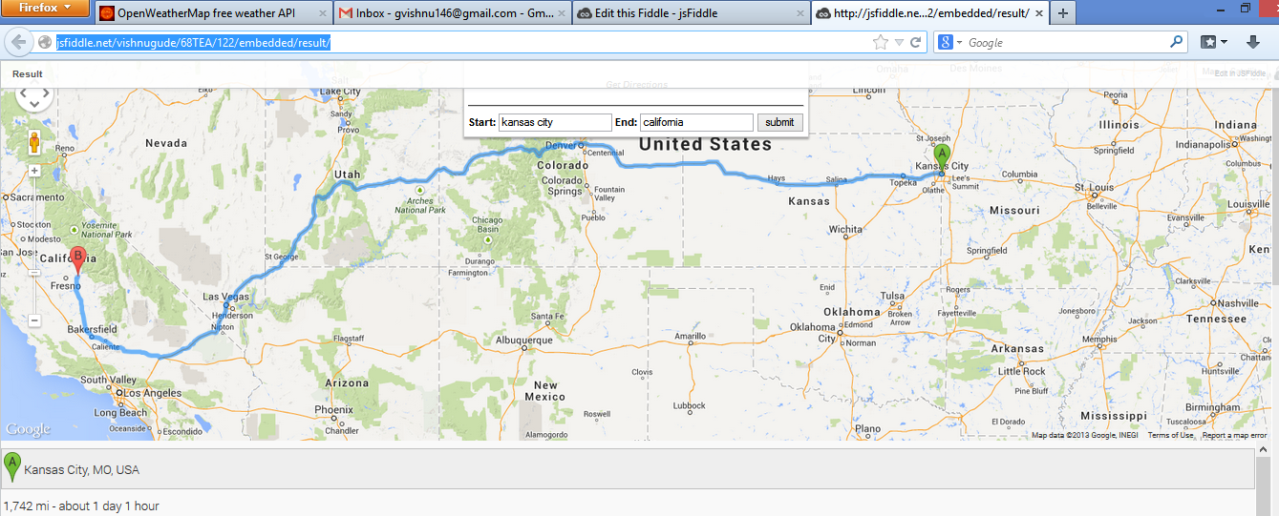

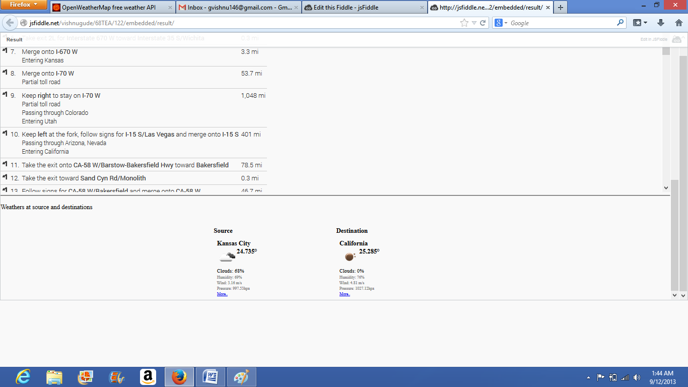

Thank You,

Vishnu Praveen Gude

16103389